* 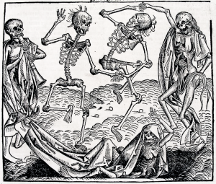To be able to investigate the causes and cures of the Black Death
* Key Words
* Symptoms
* Buboes
* Causes
* Cures
* Prevent

The Black Death

Why did the Black Death spread so easily across Britain?

Firstly the Black Death spread so easily across Britain because medieval people believed that the Black Death was caused by………………………………………………………………

This was not very good because ………………………………………………………………………………………

…………………………………………………………………………………………………………………………………………………… ……………………………………………………………………………………………………………………………………………………

……………………………………………………………………………………………………………………………………………………

Secondly the Black Death spread so easily across Britain because medieval people believed that the Black Death could be cured by………………………………………………………………

This was not very good because ………………………………………………………………………………………

…………………………………………………………………………………………………………………………………………………… ……………………………………………………………………………………………………………………………………………………

……………………………………………………………………………………………………………………………………………………

Overall I think that the Black Death spread so easily because …………………………………………………………………………………………………………………………………………………..

…………………………………………………………………………………………………………………………………………………… ……………………………………………………………………………………………………………………………………………………

……………………………………………………………………………………………………………………………………………………

HELP!!!

Would ALL the cures have worked?

HELP!!!

What did people believe at the time?